

Sleep problems in children

Lots of children find it difficult to settle down to sleep or wake up during the night. Most child sleep problems can be solved - it takes commitment and consistency. We all need sleep but sleep is especially important for children, as it directly impacts mental and physical development.

The most common sleep problems:

* poor sleep habits e.g. caused by having a screen-based device in the bedroom;
* nightmares;
* night terrors;
* anxiety – either general anxiety or anxiety about not getting enoughsleep.

**Sleep tips for school-aged children**

* Teach school-aged children about healthy sleep habits.
* Continue to emphasize need for regular and consistent sleep schedule and bedtime routine. See our Sleep Guide for more details on this.
* Keep televisions and computers out of the bedroom. Overstimulation/ being 'charged up' (e.g. too much time on electronic devices, especially before bed) impacts negatively on sleep.
* Environment is crucial to good sleep; room temperature, level of light, etc. Read [How to create a calm bedroom](https://www.thechildrenssleepcharity.org.uk/images/leaflets/The%20Childrens%20Sleep%20Charity%20Calm%20Bedroom%20Leaflets%2098341.pdf).
* Avoid caffeine (cola, hot chocolate, coffee, tea, soft and energy drinks). Read more on sleep and diet [here](https://www.thechildrenssleepcharity.org.uk/images/leaflets/The%20Childrens%20Sleep%20Charity%20Sleep%20and%20Diet%20Leaflets%2098341.pdf).

Nightmares

Nightmares are common in children and most children will grow out of them.

Nightmares may cause strong feelings of anxiety and distress. The child may wake up and may remember the dream. Nightmares in children may be caused by a frightening experience, watching a scary movie or something that is worrying them.

There is a YouTube video clip “[Why do we have bad dreams](https://www.youtube.com/watch?v=rODwoo-OeV8)?” normalising bad dreams (nightmares), this could be used to open up a conversation about having nightmares.

Parents could make a dream catcher with their child. There are plenty of YouTube clips on how to make a dream catcher, see [this](https://www.youtube.com/watch?v=pd5mOkz6-kM) simple idea of making a dream catcher.

Night terrors

Night terrors are very different from nightmares.

A child experiencing night terror may scream and move restlessly, and they may not recognize you.

The child will not be fully awake during these episodes – they may have no memory of these in the next morning.

Some medication may cause terrors. The parent could check with their GP whether there was any link between medication the child is on and night terrors.

There is also a strong link between tiredness and experiencing of night terrors.

If the child is experiencing night terrors their parent could try to change the pattern of the child's sleep cycle, by trying to wake them soon after they have gone to sleep (e.g. within an hour) then letting them to go back to sleep. Repeat this for a couple of days.

Other resources

* Read more on night terrors and nightmares [here](https://www.nhs.uk/conditions/night-terrors/)
* Do's and don’ts and resources from the *Sleep Sanctuary*, <http://www.mysleepsanctuary.co.uk/when-nightmares-strike/>
* *The Children’s Sleep Charity*website <https://www.thechildrenssleepcharity.org.uk/>

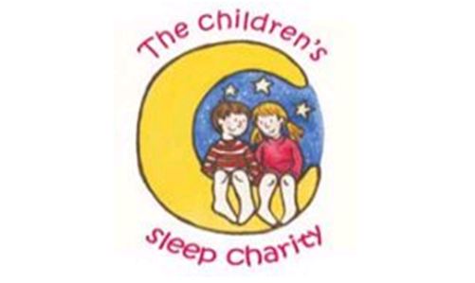

* Read a Guardian article [here](https://www.theguardian.com/lifeandstyle/2017/mar/04/go-school-two-half-hours-sleep-british-children-arent-sleeping)