Sleep

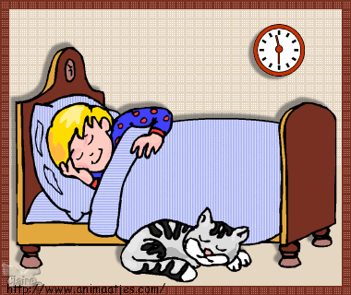

guide

Sleep questionnaire
In the last seven days how bothered your child was by:

 | Not bothered at all | A little bothered | Quite  bothered | Very bothered
Having trouble getting to sleep | 0 | 1 | 2 | 3
Waking up one or more times during the night | 0 | 1 | 2 | 3
Having bad dreams or nightmares | 0 | 1 | 2 | 3
Having trouble staying asleep  (e.g. waking up earlier than usual) | 0 | 1 | 2 | 3
Feeling sleepy during the daytime doing activities | 0 | 1 | 2 | 3
Feeling too tired to do things | 0 | 1 | 2 | 3

In the past week, how often has your child felt:

 | Not at all | A little bit of the time | Quite a lot of the time | Almost all the time
Well rested | 3 | 2 | 1 | 0
That they did not get enough sleep | 0 | 1 | 2 | 3
In a mood because of having a bad night’s sleep | 0 | 1 | 2 | 3
That they had a good night’s sleep | 3 | 2 | 1 | 0
Alert and full of energy | 3 | 2 | 1 | 0

In the past week, how would you rate your child’s sleep quality overall?

Very good Fairly good Fairly bad Very bad
Why do we need to sleep?

Sleep helps us:

- solidify and consolidate memories;
- repair muscles;
- protect the immune system;
- with our language (sustain attention, understand, summarise).

What happens if we do not sleep?

Have a look at the list below and tick any things which you think might be happening to you because you are not sleeping well.

- Feeling grumpy
- Feeling irritable
- Forgetting things
- Finding it hard to concentrate
- Finding it hard to make decisions
- Finding it more difficult to pay attention
- Feeling sadder, angrier, or more worried

It can be really frustrating when we do not get enough sleep and, often, the more you lie in bed thinking, “I need to go to sleep” the more frustrated you feel and the harder it becomes to fall asleep.

How much sleep do we need?

Adults - between seven and nine hours
Babies - between 11 and 14 hours
Young children - between nine and 11 hours
Teenagers - between eight and 10 hours

Different types of sleep

There are five different stages of sleep.

- Light sleep: We are half awake and half asleep, it might feel like you are dozing. It is easy to be woken up in this stage.

- True sleep: Our heart rate and breathing slows down. It is a bit harder for you to be woken up. Most of the time when we are sleeping, we are in this stage.

- Deep sleep: Your brain slows down, and you do not move much. Some people might sleep-walk during this stage.

- REM sleep: The brain is quite active during this stage and we have dreams. If you are disturbed in this stage of sleep, you might remember your dreams. We cannot move our muscles during this stage which stops us acting out our dreams.

Through the night we move up and down through these stages, a bit like waves going up and down.

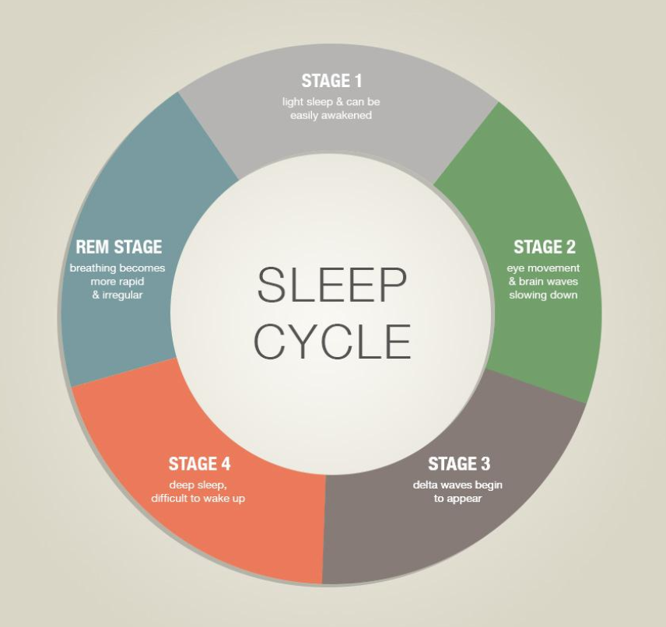
Why it might be hard to sleep

There are many reasons why people might find it difficult to sleep.

Have a look at the list below and tick any of these which apply to you:
First time away from home
Feeling unwell
Going to bed much earlier than usual
First time in custody

Feeling sad

Feeling worried
Having a lot on your mind

Having too much caffeine (e.g. tea, coffee, cola)

Feeling hungry

Changes to your usual evening routine

Not being able to do things you usually do when falling asleep (e.g. watching TV, listening to music, having the light on)

If there are other things you can think of which are making it difficult for you to sleep write them here:
………………………………………………………………………………………………………………………………………………………………………………………………………………………………………………………………………………………………………………………………………………………

Helping myself to get a good sleep
- There have been lots of suggestions about what might help people get good sleep.
- Different things work for different people.
- Often these ideas do not work straight away; you must try them for a few nights first.
- Below there are some suggestions about what might help you to get good sleep. Take a look and decide which things you would like to try.
Having a regular evening routine

When we do the same things each night before going to bed it helps our mind know it is nearly time to sleep. An example of an evening routine might be: 7.00pm I have a warm bath; 7.30pm I have a drink of Horlicks; 8.00pm I read my book; 8.30pm I go to bed and turn the lights off.

Some of the suggestions below might help you decide what to put in your evening routine.

Having a warm drink

Having a warm drink can help you to relax before bed. Remember you should not drink things with caffeine in them before going to sleep as caffeine keeps you awake.

Having a warm bath or shower

Having a warm bath or shower can also help you relax, especially if you have tense muscles. Remember not to have the water too hot or too cold though as this will make you feel even more awake.

Reading a book
Reading a book can also help you to relax as this can help us slow our minds down and take our minds off other things.
Turn the television and computer games off earlier

Having the television on while we are trying to sleep keeps our minds active and busy and will make it more difficult to fall asleep, not least because we need to concentrate on the television and keep our eyes open. The same is true for computer games; especially those which make you feel excited, scared or stressed.

Listen to music

Listening to calming music can help us go to sleep. Some young people find that there are lots of noises which they are not used to, and music can help distract them from this. It is best to listen to something calming and quiet rather than something which makes you feel excited.

Do not exercise right before bed

Doing exercise before bed releases chemicals which make us feel awake. Although it is a good idea to exercise during the day (especially if you are not feeling tired when it comes to the evening) try not to do this right before bed.

Use relaxation exercises

There are several different relaxation exercises you can try which might help you to sleep. It is best to practice these with other people who know how to use them first before trying them on your own.

There are details of how to do the different relaxation exercises on separate sheets.

Top tips for getting a good sleep

- Try and keep to a regular routine before bed.

- Try and avoid things which make you feel strong emotions before going to bed (e.g. angry, scared, worried, upset).

- Even if you are feeling tired during the daytime, try to avoid naps as this will make you feel less tired in the evening.

- If you are lying in bed for more than 30 minutes and cannot fall asleep do not lie there feeling frustrated. Try some of the relaxation techniques as these can distract your mind and relax your body.

- For some of the ideas on these sheets to work you must try them for a few nights in a row.

- If you are still having trouble sleeping then tell a member of staff, especially if you are having trouble sleeping because you feel sad, worried or angry about something.

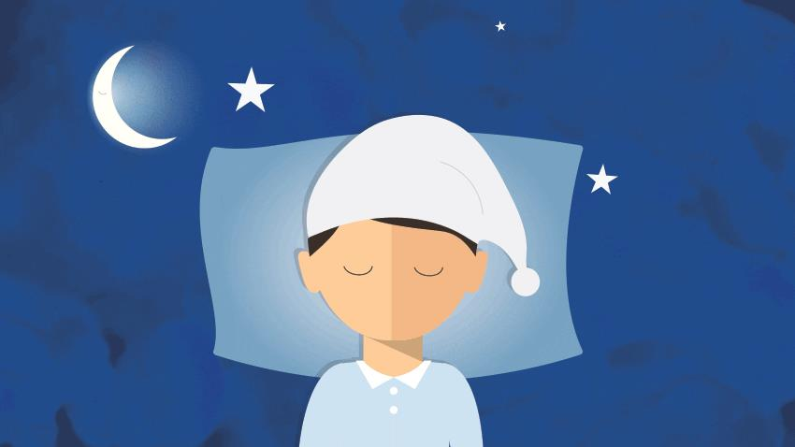
Sleep diary

It can be a good idea to keep a sleep diary so that you can see if your sleep is improving and which of the ideas are working for you.

 | Day 1 | Day 2 | Day 3 | Day 4 | Day 5 | Day 6 | Day 7
What time did you go
to bed?
How long did it take
you to fall asleep?
How may times did
you wake up in the
night?
How good was your
sleep (5 = brilliant, 1 = very bad)

Controlled breathing

When we are feeling worried, stressed or angry our breathing can speed up. Controlling our breathing can help us to calm down.

It may help to close your eyes while you do this, but you do not have to.


Start by breathing in through your nose while counting to three. Make sure that you can see your stomach moving out while you do this.

Breathe out through your mouth while counting to three. You should see your stomach move back in.

Keep breathing in and out slowly like this, concentrating on counting to three each time and focusing on your breathing.

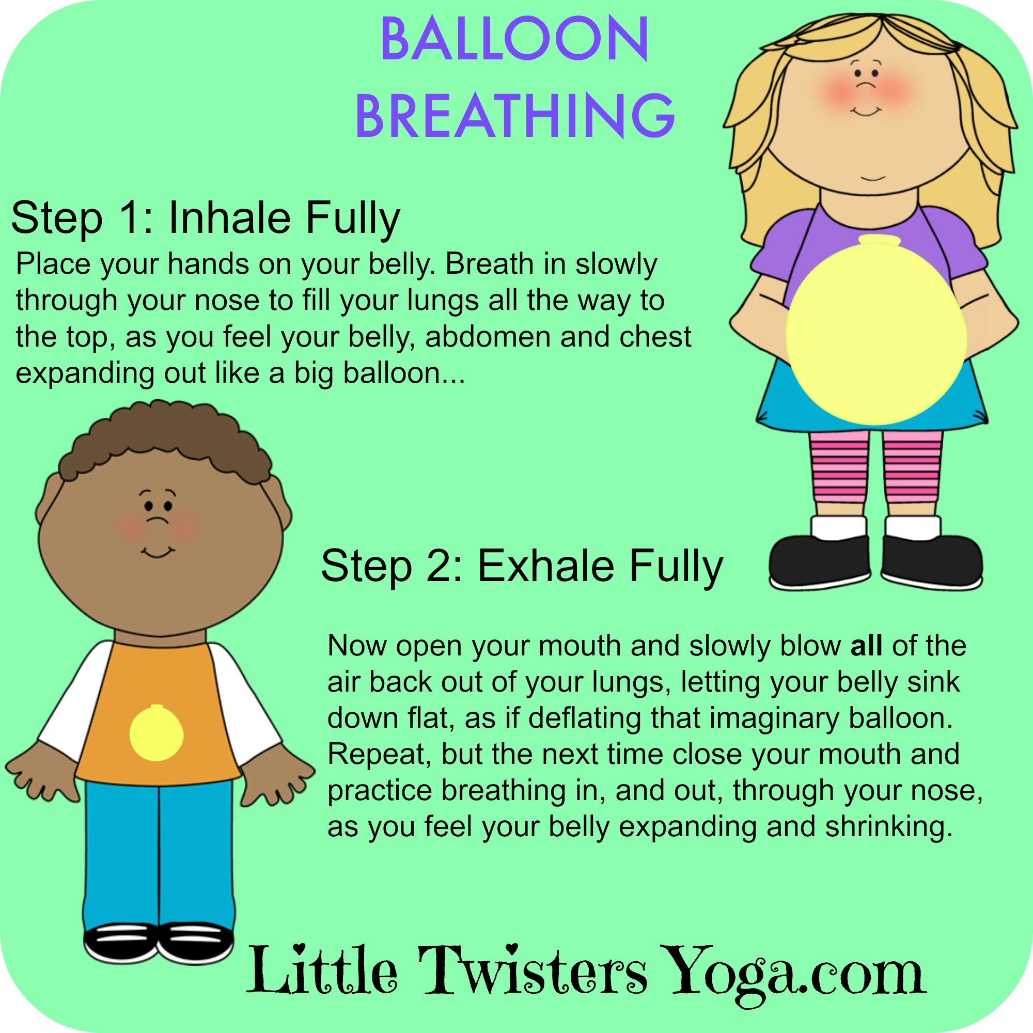
Muscle relaxation

When we are feeling worried, stressed or angry our muscles can tense up. Relaxing our muscles can help us calm down. Work from the bottom of your body to the top.

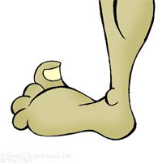
1. Tense up all the muscles in your feet. Hold it for five seconds then let them relax. Do this three times.

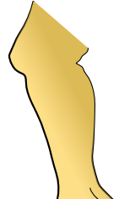
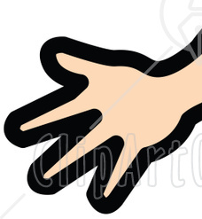
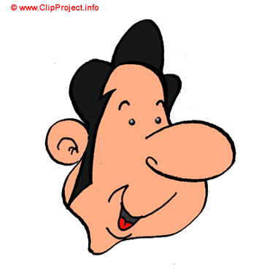
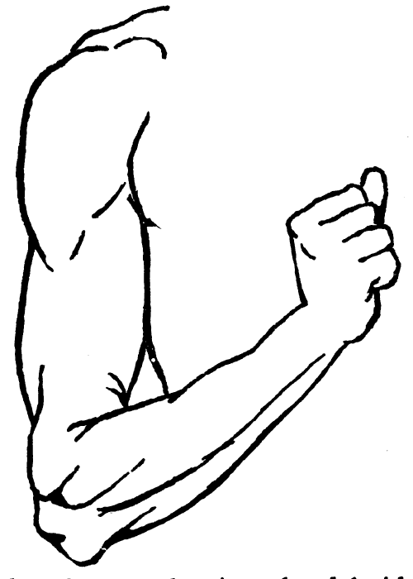
2. Tense up all the muscles in your legs. Hold it for five seconds then let them relax. Do this three times.
3. Tense up all the muscles in your stomach. Hold it for five seconds then let them relax. Do this three times.
4. Tense up all the muscles in your chest. Hold it for five seconds then let them relax. Do this three times.
5. Tense up all the muscles in your arms. Hold it for five seconds then let them relax. Do this three times.
6. Tense up all the muscles in your hands. Hold it for five seconds then let them relax. Do this three times.
7. Tense up all the muscles in your face. Hold it for five seconds then let them relax. Do this three times.

Other resources:

The Children’s Sleep Charity
https://www.thechildrenssleepcharity.org.uk/


You can find other relaxation, visualisation and meditation expertise on headspace here


The Sleep Sanctuary
http://www.mysleepsanctuary.co.uk/when-nightmares-strike/

Relaxation top tips from The Children’s Sleep Charity

The Guardian case study article here

