Anxiety

What is anxiety?

Anxiety is one of many feelings we have. Anxiety is a normal human emotion and we all feel it from time to time. Anxiety can be experienced in our bodies (sometimes referred to as stress); when we feel anxious or stressed, we may experience tension in our body, feeling sick or shaking.

Another component of anxiety is the way how we think, also referred to as worry. When we are anxious or worried, we may experience thoughts of not feeling able to do something “I will not cope”, worrying about the future, such as “What if...”.

The third component of anxiety is our behaviour, such as avoidance or excessive reassurance seeking.

Experiencing anxiety is not dangerous, and although it feels unpleasant, it serves an important protective function. In fact, it can be very helpful e.g. if we did not worry about doing well in exams we may not be motivated to revise for them. If we were not anxious about getting hurt by a car while crossing road, we may not have waited, looked left and right, listened for any potential cars approaching, and ensured that it was safe to cross the road.

Anxiety could be understood as the FFF model, or Fight-Flight-Freeze response - you may like to watch a YouTube clip explaining the model: [Younger Children](https://www.youtube.com/watch?v=FfSbWc3O_5M) or [Young People](https://www.youtube.com/watch?v=jEHwB1PG_-Q)

Most children will worry, feel stressed and anxious, or will have difficulty sleeping or being away from their caregiver from time to time.

However, anxiety can become a problem when the perceived danger is not actually dangerous and we may experience too much anxiety and this may lead us to stop doing things we need and want to do, such as going to school and socialising, and avoid places and activities we have previously enjoyed. We may start thinking of the worst thing that could happen in a situation, or excessively worry about the future or what others think of us. As we concentrate on these a lot and also avoid things that bring us joy in our lives, we may become sad, upset and feel depressed or angry.

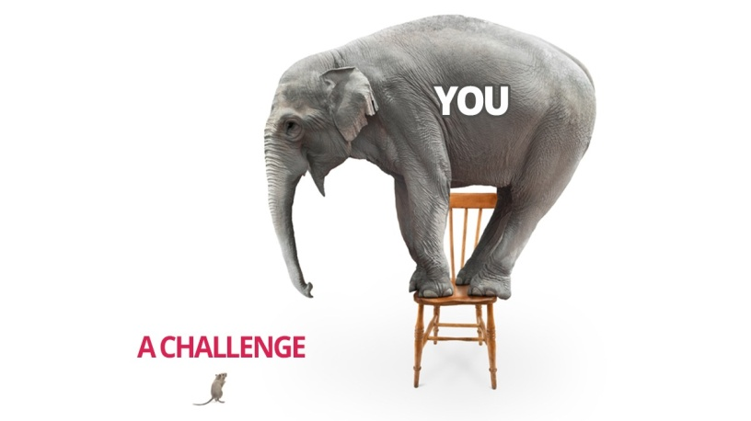Anxiety can be summarised:

Overestimate the danger

Anxiety = ----------------------------------------------------------------------

Underestimate our ability to cope

Anxiety problems are often missed. If you suspect a child is experiencing problematic anxiety it is important to **ask them about it**.  
  
Also it is important to remember that no two people will experience or exhibit signs and symptoms of anxiety the same…

The most common signs and symptoms that may suggest problematic anxiety are:

* spending time alone;
* not interacting in class;
* looking physically anxious;
* using the toilet often;
* having a temper outburst or ‘freezing’ if a demand is placed on them;
* having difficulty concentrating;
* not sleeping, or waking in the night with bad dreams;
* not eating properly;
* constantly worrying or having negative thoughts;
* feeling tense and fidgety, always crying;
* being clingy;
* complaining of tummy aches and feeling unwell.

What keeps problematic anxiety going?

Reassurance

All parents reassure their children. It is a natural response, and in some situations, it may seem to reduce distress. Anxious children often seek out reassurance from the adults and others and therefore it is not surprising that adults respond to these requests, but the more adults give reassurance, the more the child will want it. See the **how to support the anxious child** section to find out what you could do instead of using reassurance).

Avoidance

Avoidant behaviours are considered to be unhelpful coping strategies that in a short period of time bring immediate relief from heightened anxiety. However, the more we avoid anxiety-provoking situations the more anxious we may feel. Avoidance keeps the anxiety going.

How to support an anxious child?

Cutting out reassurance

Children need to be able to feel that they can deal with their anxieties/fears on their own and test out for themselves whether their worried thoughts are accurate.

Instead of giving reassurance, adults should show empathy by validating the child’s feelings (e.g. “I can see you are upset and worried by this and it is really hard”) but then help their children to think more for themselves by following the steps below:

* asking questions not giving answers;
* “what is the evidence to support the thought?”;
* consider alternative evidence;
* help your child to consider different possibilities.

Cutting out reassurance can be attempted gradually and in a way that feels comfortable for the parents**. Cutting out reassurance is not about not responding, it is about responding differently**. Parents can be encouraged to reduce reassurance by remembering to **ask their child questions, rather than give answers.**

Thinking like a judge in court - see the book for details

1. Identify a suspect (thought)
2. Investigate other suspects (alternative evidence)
3. Make a judgment about the first suspect (is the thought realistic or helpful?)

Ultimately the idea is to try and help the child to consider other possibilities so they can put their fear to the test and find out what really happens.

This cognitive approach gets children to think for themselves, and in effect helps them to remember the conclusions that were drawn because they have worked them out for themselves.

Gradually facing fears instead of avoidance

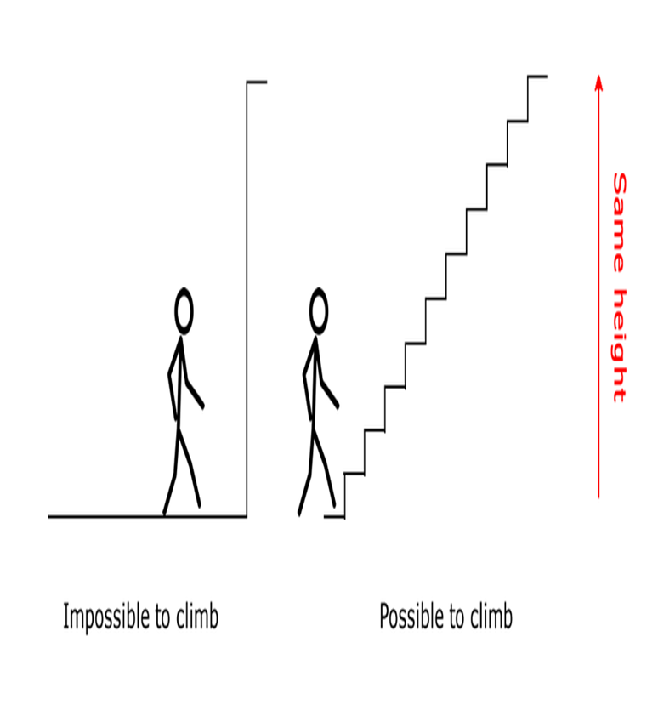

Instead of avoiding situations that children find anxiety-provoking, adults may support them to face their fears. They could do this by gradually exposing themselves to a feared situation, starting from the easiest or least anxiety-provoking and then moving up step by step, getting used to and learning for themselves that they can do it.

(Information is based on the advice from the book Overcoming your child’s fears and worries.)

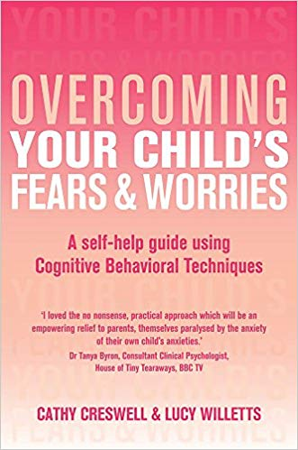

What other things could you do to support an anxious child?

* Read stories about children experiencing anxiety.
* Discuss the physiological symptoms that can be experienced when anxious.
* Talk about anxiety as being something everyone experiences.
* Do not get drawn into anxious moments - stay calm.
* Provide safe opportunities to experience anxiety (gradual exposure).
* Encourage the child to tolerate their anxiety.
* Do not avoid things just because they make a child anxious - this may reinforce their fears.
* Do not ask leading and closed questions, but think things through with them.
* Try to model healthy ways of handling anxiety. If you suffer from problematic anxiety you may find reading this information useful. Also you may like to access support for yourself (speak to your GP or contact italk Talking Therapies Services to self refer on their website <https://www.italk.org.uk/>).
* Encourage and praise brave behaviours. Be specific when praising the desired behaviours.
* Ensure your child gets enough sleep, nutritious food and enough exercise.
* Ensure that the child gets enough rest and chances to relax.

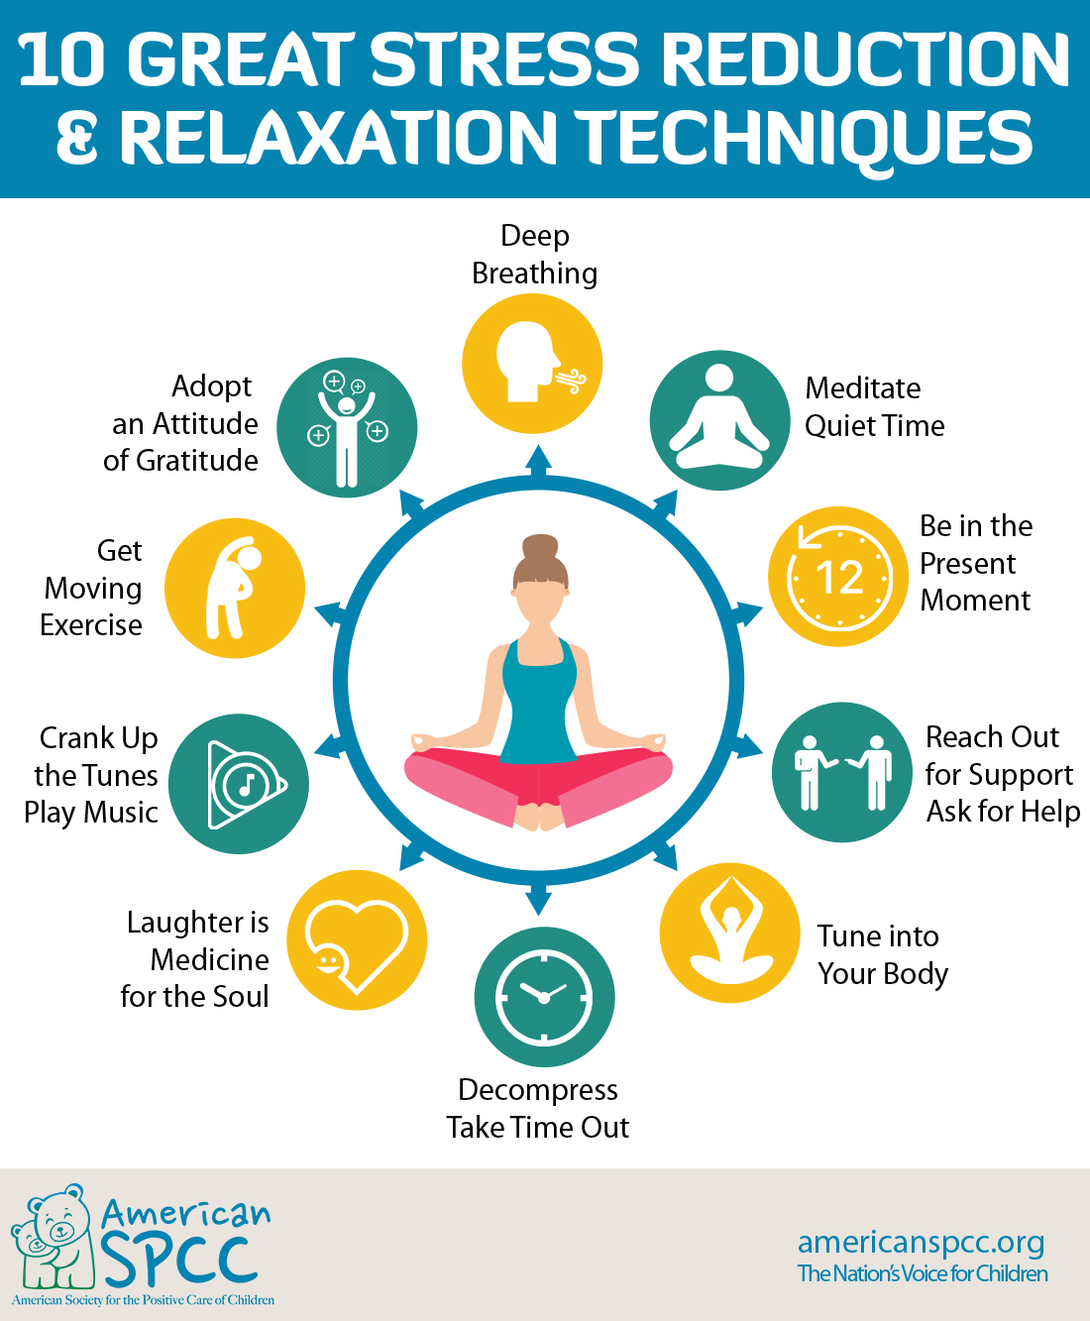

What can you do to help a child presenting with problematic anxiety?

As mentioned earlier, anxiety and worries are normal part of child’s development. An example of this is how infants show fearful reactions to loud noises and heights; how toddlers react to strangers, animals, the dark or being alone; and later in childhood, how they develop anxieties around school and social interactions.

However, if anxiety is persistent and intensive, leading them to avoid situations and causing a lot of upset then parents/teachers can contact the local CAMHS (Child and Adolescent Mental Health Services) team to discuss whether a referral to mental health services (CAMHS) would be beneficial.

Useful websites & other resources

* [www.YoungMinds.org.uk](http://www.youngminds.org.uk/)
* [www.Getselfhelp.co.uk](http://www.getselfhelp.co.uk/)
* [www.Moodjuice.scot.nhs.uk](http://www.moodjuice.scot.nhs.uk/)
* [www.AnxietyBC.com](http://www.anxietybc.com/)
* You could download a self-help booklet “How to beat anxiety” from the Hampshire CAMHS website [**https://hampshirecamhs.nhs.uk/?s=self-help**](https://hampshirecamhs.nhs.uk/?s=self-help)

**Books**

**Younger children**

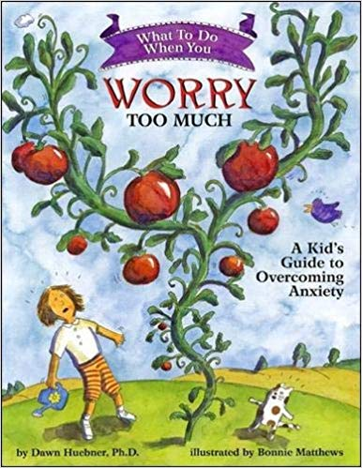“What to do when you worry too much: A kid's guide to overcoming anxiety” (What-to-do guides for kids) by Dawn Huebner

“Morris and the bundle of worries” by Jill Seeney

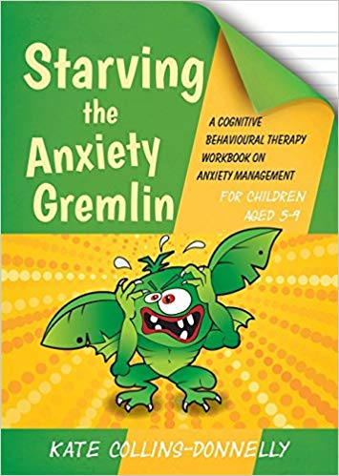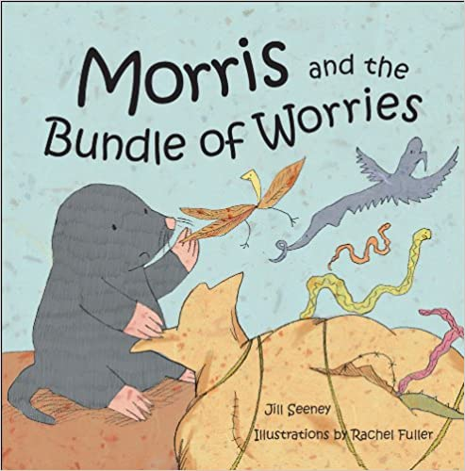

“Starving the anxiety gremlin for children aged 5-9: A cognitive behavioural therapy workbook on anxiety management”

Book by Kate Collins-Donnelly

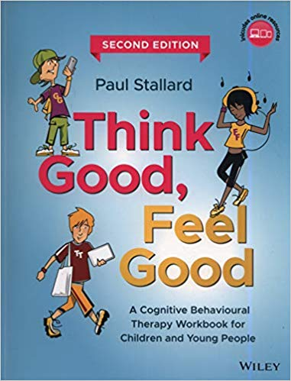

Young people

“Think good - feel good: A cognitive behaviour therapy workbook for children and young people”

Book by Paul Stallard

# Starving the Anxiety Gremlin“Starving the anxiety gremlin - A cognitive behavioural therapy workbook on anxiety management for young people - Gremlin and Thief CBT Workbooks”

Book by Kate Collins-Donnelly

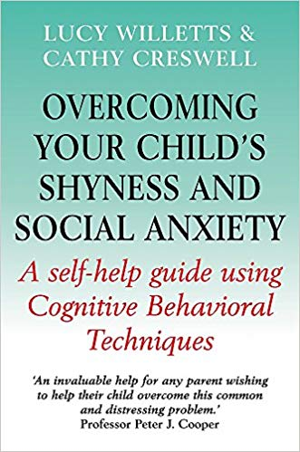

Parents

“Overcoming your child's fears and worries”

Book by Cathy Creswell and Lucy Willetts

“Overcoming your child's shyness and social anxiety”

Book by Cathy Creswell and Lucy Willett

Helplines

* [www.nopanic.org](http://www.nopanic.org)

No Panic specialises in self-help recovery and services include providing people with the skills they need to manage their condition and work towards recovery, enabling them to lead more fulfilled lives.

Crisis Number for 24/7 recording of breathing techniques on 01952 680835

Confidential helpline 10am - 10pm on 0844 9674848

* The Mix [www.themix.org.uk](http://www.themix.org.uk)

If you are under 25 you can talk to The Mix for free on the phone, by email or on their web chat. You can also use their phone counselling service or get more information on support services you might need.

Free phone: 0808 808 4994 (1pm - 11pm daily)

* Young Minds Crisis Messenger - provides free, 24/7 crisis support across the UK if you are experiencing a mental health crisis - just text YM to 85258.

All texts are answered by trained volunteers, with support from experienced clinical supervisors.

Texts are free from EE, O2, Vodafone, 3, Virgin Mobile, BT Mobile, GiffGaff, Tesco Mobile and Telecom Plus.

* Childline – children and youn people under 19 years can confidentially call, email or chat online about any problem big or small.

Free phone 24-hour helpline: 0800 1111