Trauma

What does trauma mean?

When we talk about trauma in psychological terms, we mean an emotional wound caused by traumatic events or experiences that are life threatening and stressful in nature.

These experiences are physically or emotionally harmful and have a negative impact and lasting adverse effects on the person’s functioning, mental health, wellbeing, and physical health. Common examples of trauma that children and young people experience include exposure to abuse, neglect, homelessness, domestic violence, violence in the community, loss, serious incident, life threatening illness, painful medical procedures, and natural disaster.

Post-traumatic stress (toxic stress) refers to the response that was triggered by the traumatic events on the child’s mind and body, and may result in heightened anxiety, hypervigilance, grief, negative self-image, defiant and aggressive behaviours, problems with concentration, sensory processing difficulties, sleep problems and emotional dysregulation.

However, it is important to say that traumatic stress is not necessarily an inevitable consequence of a traumatic event itself - traumatic stress is linked to the individual resources and ways they use to cope with it. Every child is unique and copes with events differently, therefore it is very subjective.

Types of trauma

Acute - a single event that lasts for a short time, e.g. car incident, medical trauma.

Chronic - the experience of multiple, prolonged traumatic events or situations.

Complex - a specific type of chronic trauma on children. It occurs (or starts) in a very young age and is interpersonal in nature, very often related to the relations children have with the adults who are in a caring role. This type of trauma is also called *developmental and relational*.

Intergenerational (transgenerational) - when untreated trauma of one generation influences the next generations, e.g. untreated trauma of a parent manifesting by way of addiction or mental health problems will have an effect on the child’s development through epigenetic ways, the level of stress the system experiences, and the disruption in attachment relationships between that parent and child (neglect, rejection, violence).

Collective - trauma shared by a group of people (community, society, nation) e.g. natural disaster, war.

Window of tolerance

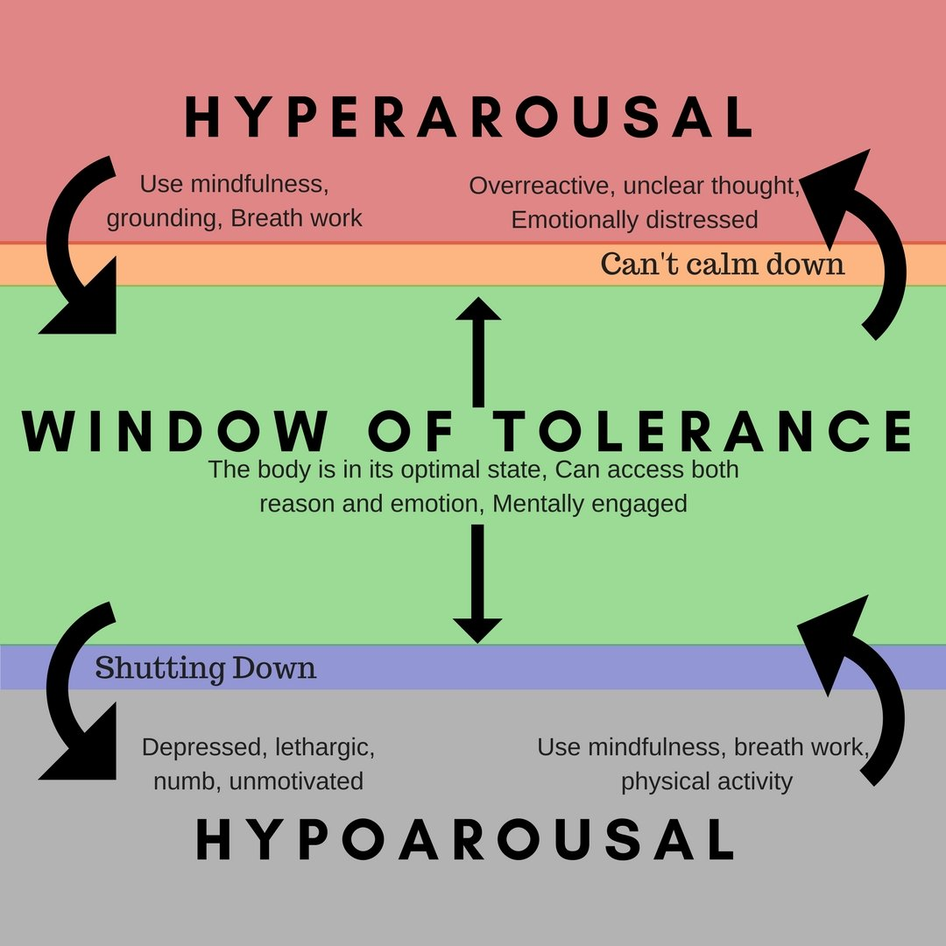

Another way we could try to understand the effect of trauma is the notion of *window of tolerance* - when our nervous system operates within the window of tolerance (green rectangle in the middle) we are at our best, responding resiliently to life stresses. However, a normal and predictable response to threat is ‘fight, flight or freeze’ reaction. As the threat level increases, the brain and body move out of the optimal zone and go into a state of hyper or hypo-arousal, chaos or increased rigidity. Those states, outside of the optimal window of tolerance refer to the states of increased anxiety, fear response and angry outbursts, depression and lethargy. Everyone’s window of tolerance is a different size. The optimum is to stay within the harmonious window of tolerance. When the person feels safe and in co-regulated positive relationships, they are within their window.

There are also practices to support with this, such as mindfulness, physical exercise, breathing and calming techniques. Children who experienced complex trauma may need more support to help them to remain within and expand their window of tolerance. They will need integrated support involving their teachers and other important adults in their life.

Watch this YouTube animation by Beacon House explaining [the window of tolerance](https://www.youtube.com/watch?v=Wcm-1FBrDvU).

Tips for teachers

1. Learn about trauma and attachment. Understanding the effects of traumatic experiences helps us to look beyond the child’s behaviour and enables us to increase the understanding of the child’s needs and triggers
2. Stay close. Find a place for the pupil close to you, which is next to a calm pupil. Build a positive relationship with the pupil - let them know that you ‘hold them in mind’. Ensure that you have a good structure in place and they know what to expect from you. When you talk to the pupil use their name and give eye contact. Distinguish between the pupil and their behaviour. Praise the pupil for trying, and not just for final achievements. You could treat the pupil as they were your helper - give them a simple task to carry out.
3. Introduce break times for relaxation, exercise, stretching, or play times.
4. Stay calm and bring calm. Maintain your own emotional stability, introduce sensory breaks and create pauses.
5. Encourage the pupil to pursue their interests, develop their talents and hobbies and strengths.
6. Talk to your colleagues about the use of reflective practice and supervision.
7. Be aware of your own stress and burnout.
8. Practice self-care.
9. Seek support if you recognise your own trauma. You may want to access therapy or counselling to help you process your own experiences.

“Our emotional states are so contagious! When we’re tense, others around us tend to become tense. When we are happy, we tend to make others a bit happier. If we as educators are feeling angry, our pupils will tend toward anger, or at least toward a tense, defensive state, raised to protect themselves from our anger. Such states reduce our vulnerable pupils’ readiness to lean and our ability to influence them, without resorting to power and control.”

(Bomber and Hughes, 2013)

Helpful resources

Websites



<https://www.helpguide.org/home-pages/ptsd-trauma.htm>

Information and self-help support for individuals affected by PTSD and trauma.



<https://beaconhouse.org.uk/resources/>

Link to freely available resources and further websites for children, young people, their families and professionals for individuals who have experienced trauma and loss.



<http://assisttraumacare.org.uk/our-service/children-are-affected-too/>

Trauma Informed Schools UK <https://www.traumainformedschools.co.uk/>

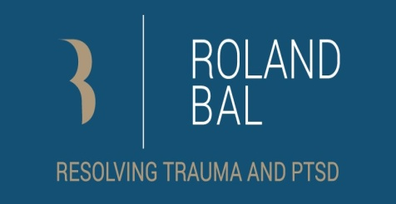

Roland Bal: Resolving Trauma and PTSD <https://rolandbal.com/child-abuse-articles/>

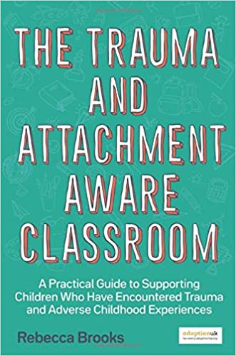Books

*The trauma and attachment-aware classroom:* A practical guide to supporting children who have encountered trauma and adverse childhood experiences

Book by Rebecca Brooks

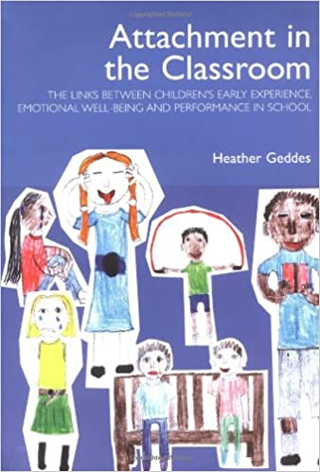

*Attachment in the classroom:* A practical guide for schools

Paperback by [Heather Geddes](https://www.amazon.co.uk/Heather-Geddes/e/B001K7PJA8/ref=dp_byline_cont_book_1)

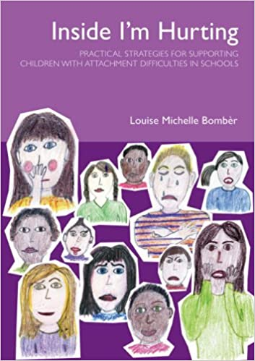

# *Inside I'm hurting:* Practical strategies for supporting children with attachment difficulties in schools

# Paperback by [Louise Michelle Bomber](https://www.amazon.co.uk/s/ref=dp_byline_sr_book_1?ie=UTF8&field-author=Louise+Bomber&text=Louise+Bomber&sort=relevancerank&search-alias=books-uk)

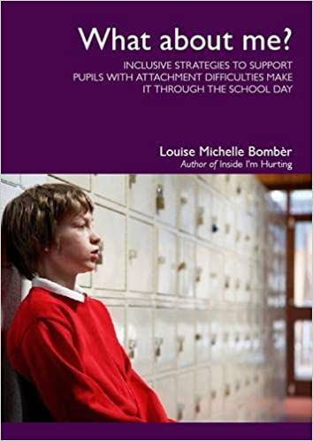

# *What about me?*I Inclusive strategies to support pupils with attachment difficulties make it through the school day

# Book by [Louise Michelle Bom](https://www.amazon.co.uk/Louise-Michelle-Bomb%C3%A8r/e/B0034PCY4S/ref=dp_byline_cont_book_1)ber

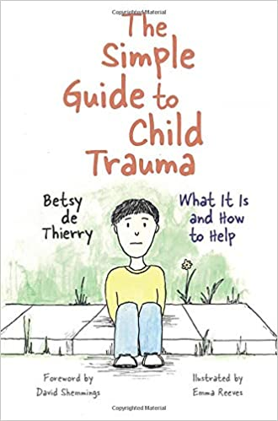

# *The simple guide to child trauma*: What it is and how to help

# Simple guides by [Betsy de Thierry. Foreword by David Shemmings](https://www.amazon.co.uk/s/ref=dp_byline_sr_book_1?ie=UTF8&field-author=Betsy+de+Thierry.+Foreword+by+David+Shemmings&text=Betsy+de+Thierry.+Foreword+by+David+Shemmings&sort=relevancerank&search-alias=books-uk)